BIDC User Interface Errors

* CNC Gantry Sheet router shows that I need more training but I’ve taken the quiz
* Clicking on the link takes me to passport which was nice but then once I had logged in it didn’t give me the option to take a quiz, it just showed this page with no buttons I could press

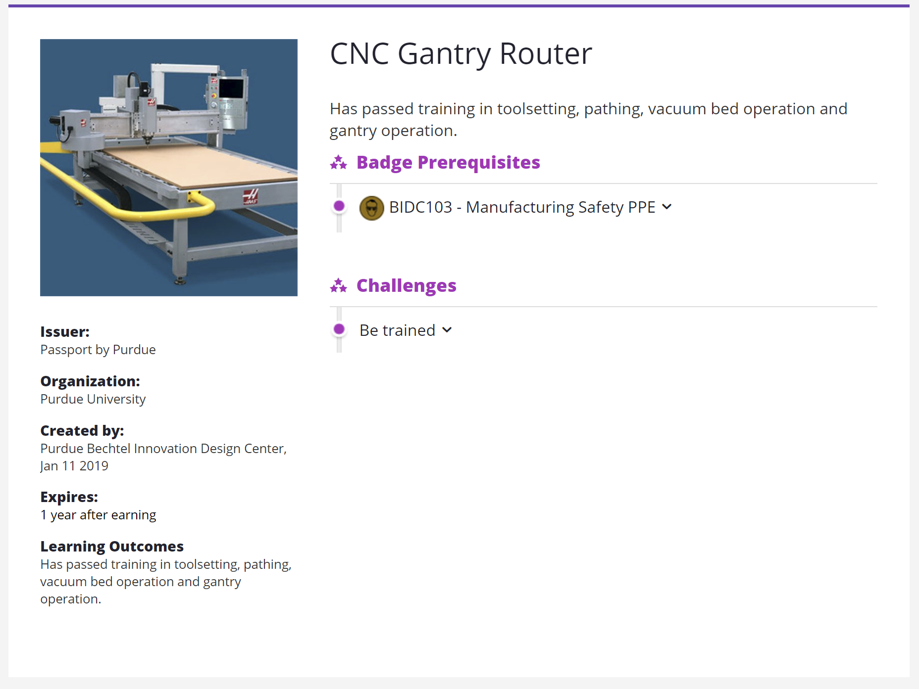

* The horizontal bandsaw quiz doesn’t expire
* The format of the “State Active” with Health right underneath it makes it look like there should be something next to it, but I guess the “Health” part is all the icons underneath?
* I clicked on the link that is on my name and it rerouted the tab to something that said I was “User 19” and that was all there was. I clicked the back arrow and it doesn’t return to the same page. It says

Confirm Form Resubmission

This webpage requires data that you entered earlier in order to be properly displayed. You can send this data again, but by doing so you will repeat any action this page previously performed.

* Press the reload button to resubmit the data needed to load the page.

ERR_CACHE_MISS

* What is the difference between Projects and My Projects on the home page?
* Make the Project tab bigger at the top